

**A**

**REFLECTIVE DIARY**

ON

**PROJECT 3: CRIME ANALYTICS CRIME ANALYSIS.**

**SUBMITTED**

**IN PARTIAL FULFILLMENT TO THE**

**MODULE**

**BUSINESS INTELLIGENCE AND DATA VISUALIZATION**

**BY**

**ORJI, CHIAZOKAM CHIMZURUM**

**21066371**

**MAY 2022**

**Table of Contents**

1. Introduction…………………………………………………..................
2. Literature Review of Related works………………………....................
3. Milestone 1
4. Data exploration …………………………………………...............
5. Milestone 2
6. Business requirement and identify stakeholders
7. Milestone 3
8. Data visualization and answer to business question……………
9. Milestone 4
10. Storytelling around the data……………………………………
11. Milestone 5
12. Recommendations ……………………
13. Limitations....................................................................................
14. Learning outcomes……………………………………………...
15. Conclusion……………………………………………………………….
16. Reference…………………………………………………………………

**Introduction**

A reflective diary records a person’s learning experience with the aim of integrating and expressing all learnt through reflection (Anon., 2022). In this Reflective diary, we review the progression, trend, or evolution of crime across various states in the United States of America. A crime analysis involves the use of investigative tools to analyse valuable quantitative and qualitative data. It is an extremely important process because of the insights and information this analysis can give to law enforcement agencies and communities (Overland Park, 2014). There are different types of crime analysis, crime intelligence analysis, tactical crime analysis, strategic crime analysis, and administrative crime analysis. I used the administrative crime analysis because I aim to present interesting findings and outcomes at the end of this analysis instead of just research and statistical analysis (Boba, 2001). For this project, I studied the dataset to comprehend it and created a report using visual representations to clearly illustrate and present a precise storytelling and data-driven recommendations.

The concept of data visualisation used by crime data analysts coupled with improved computerized systems have proven helpful to Law enforcement agencies in preventing, investigating, and solving crimes.

**9th February      Group Selection**

Today, we were told by Haixia about our project for the semester and we were to form project groups. There was need to form a group of 4, being that we were four sharing a table at the time, we quickly decided it made sense to create a group together. Hence, group 10 was formed.

**11th February 1st Team’s Meeting**

Today was our first group meeting. We decided to get to know each other and get familiar with Tableau. We wanted to ensure everyone has successfully downloaded and installed Tableau with no issues. After the meeting, I realized I was struggling with understanding some aspects of Tableau, so I decided to go through the Tableau tutorials shared by Haixia on blackboard and practice with the sample superstore data. I also watched a YouTube video, ***Tableau Training for Beginners by Edureka.*** This, alongside the tutorial, proved extremely helpful and informative.

**15th February**

I decided to go through the project topics and datasets provided in the course specification today. We were given three topics to choose from and I wanted to review and understand each of them before my team and I decided on one. All the project topics were interesting, but Project 3 caught my attention immediately. Working on an actual crime dataset gave me the feeling that I was directly contributing to reducing crime and victimization.

**16th February      Project Selection and registration**

My group met today as a team to decide which project we would work on. I suggested crime dataset and gave reasons being that we could possibly help reduce crime and save lives. My teammates also shared the same thoughts, so we decided to analyze Project 3. The idea of acting as investigators to recognize crime pattern and provide result that could potentially help various law enforcement agencies combat and reduce crime with proper planning and strategies, felt exciting. We then proceeded to register our Project group and topic on the link provided on blackboard. We also decided to use Tableau for our analysis and visualization.

**17th February**

Today was our first Industry Advisor meeting. I hadn’t started exploring the data yet since we had just selected the project. Therefore, I had no exact questions regarding the dataset. I was however open to learning from the experienced advisor and, get ideas on how to proceed with the analysis and visualizations. There were some key takeaways for me from the meeting. I learnt specifics about crime analysis and the different types of crime analysis which made my team and I decide to use the Administrative Crime analysis type for our project. I also learnt that my visualizations should not be designed in a way that it impacts the efficiency of the report.

**18th February 2nd Team’s Meeting**

We had our second group meeting today with plans to familiarize ourselves with the dataset using tableau. We tried to view the geographic location of the dataset on a map, but all the locations were indicated as “unknown” as seen in the circled area in the image below.

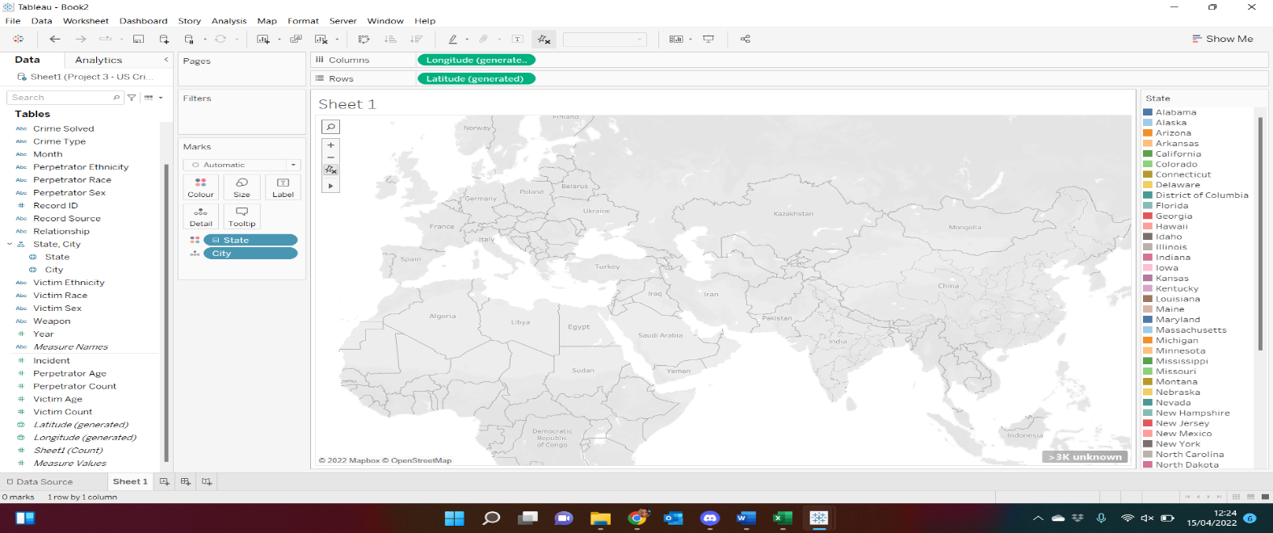





We found a way to resolve this issue on the official Tableau support site which is to edit the location. I proceeded to edit location from United Kingdom to USA, changed the geographic role from City to County and manually edited the few remaining unrecognized names by typing in the recognized names. The entire step can be seen in the screenshots below.

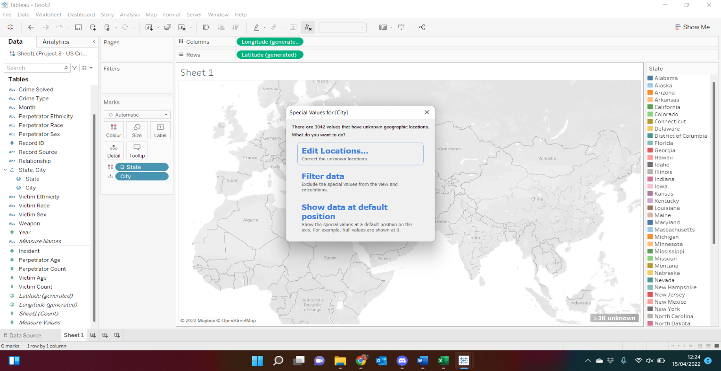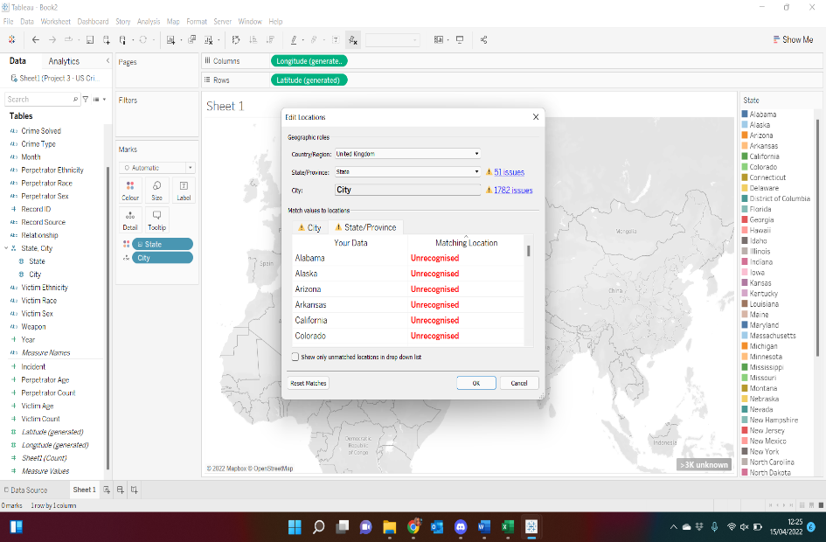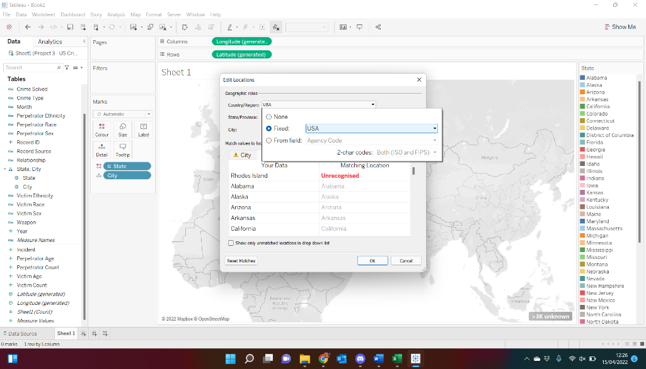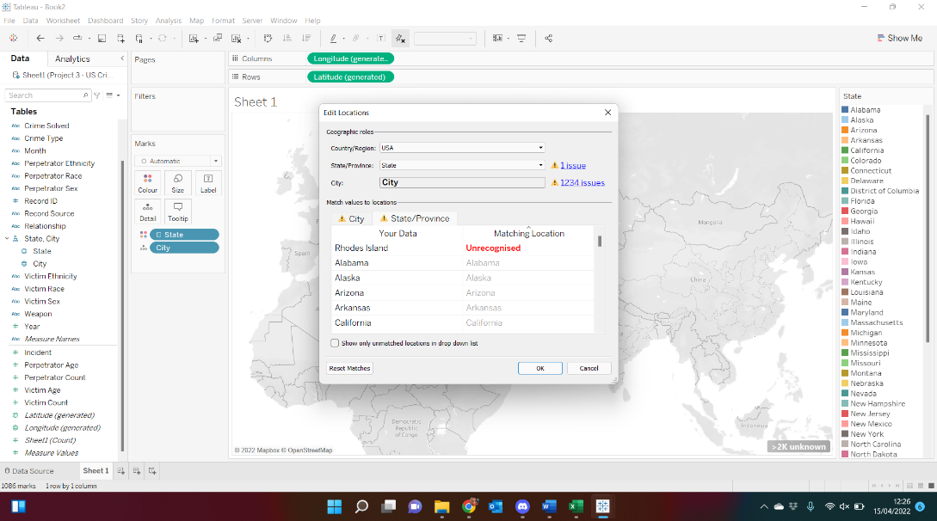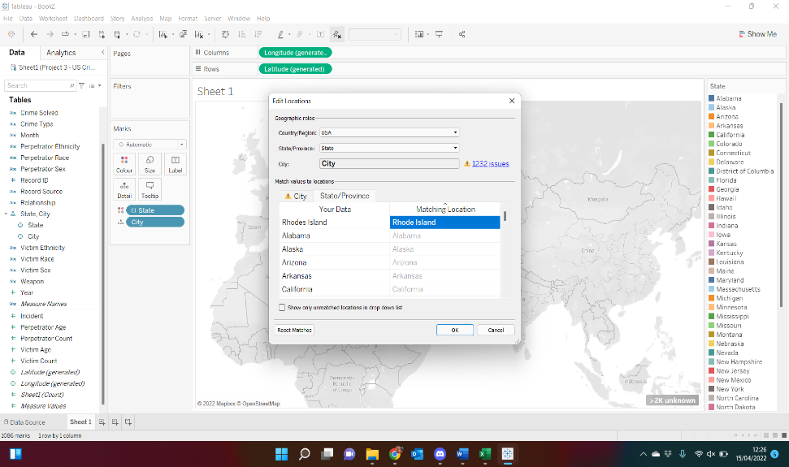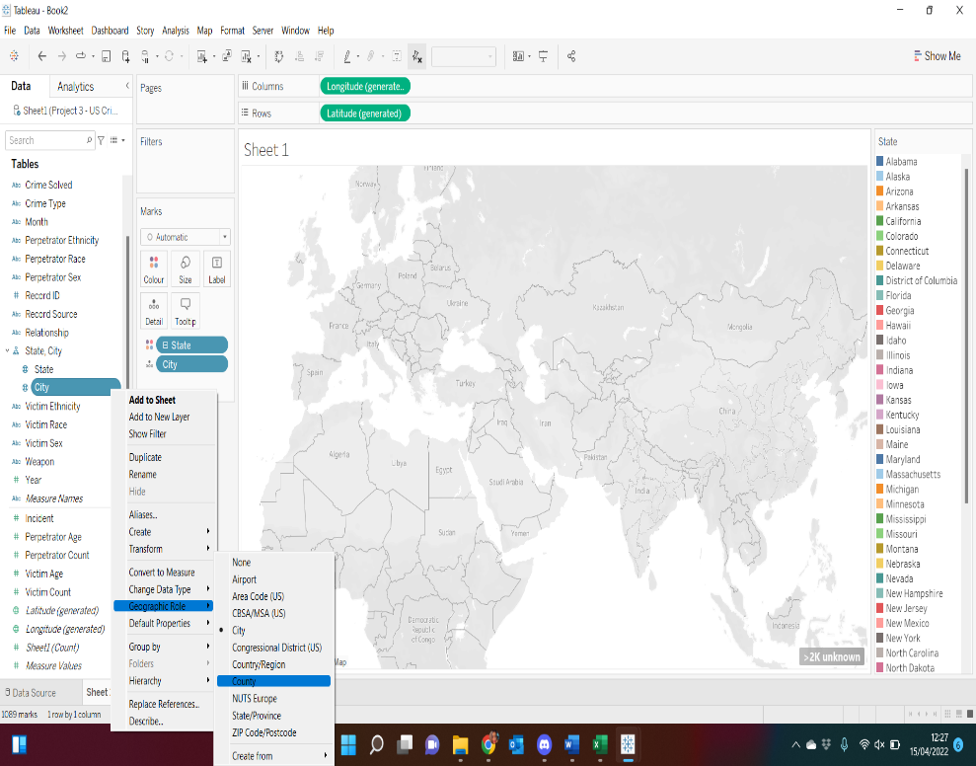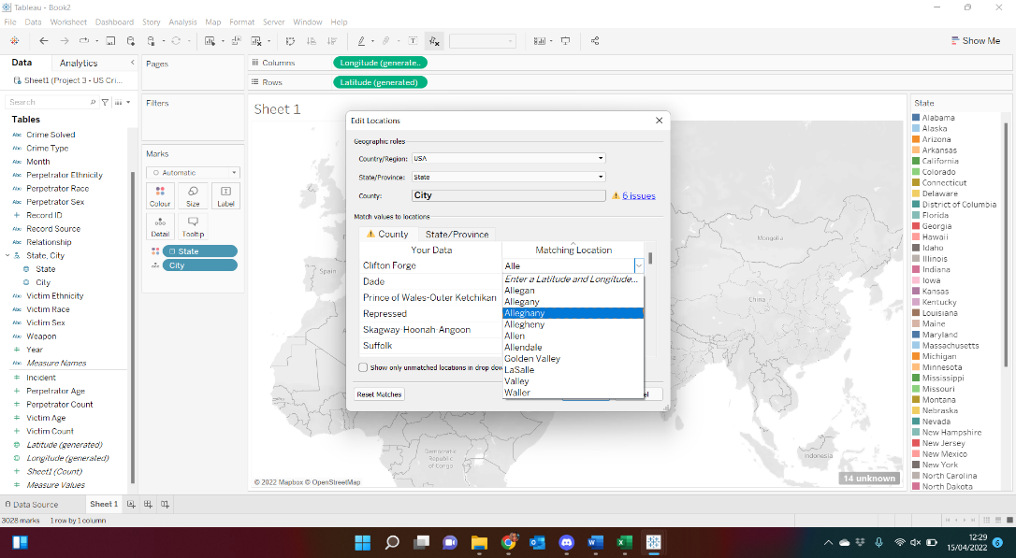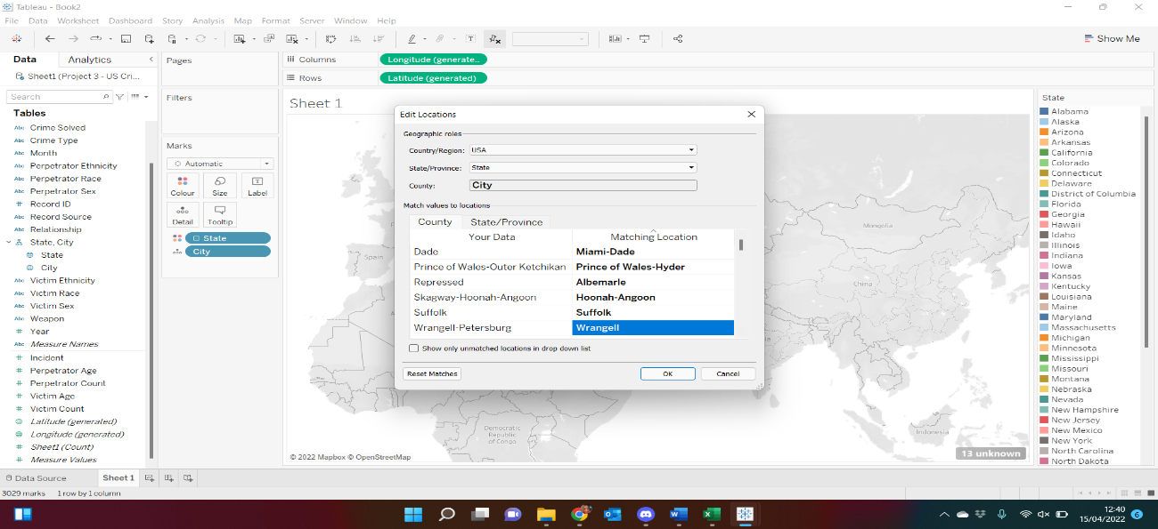



**20th February**

Today, I went further to study and understand the dataset. I discovered that there are two crimes recorded in the dataset and they are Murder or Manslaughter and Manslaughter by Negligence. I felt these two crime types recorded did not give a full picture of the specific crimes committed, I therefore decided to research on them for more details. The research I did made me understand that Manslaughter by Negligence or Gross Negligence as popularly known arises in situations where the offender owes the victim a duty of care but breaches that duty. The offender’s actions are scrutinized and if found bad, will be regarded as an omission or criminal act. Circumstances like doctor-patient relationship, or a babysitter and the child are circumstances where duty of care exist automatically (A Guide to Manslaughter by Gross Negligence | Stuart Miller Solicitors, 2021).

‘Murder’ and ‘Manslaughter’ together, constitute Homicide but they both mean different things (Homicide: Murder and Manslaughter | The Crown Prosecution Service, 2021). Homicide is the killing of one person by another. ‘Murder’ refers to offences where the offender had the intention to kill or cause grievous harm to the victim while ‘Manslaughter’ is a general term for crimes where a life is lost, but no proof of the offender’s intent to commit such crime (A Guide to Manslaughter by Gross Negligence | Stuart Miller Solicitors, 2021).

Overall, I discovered the two crime types recorded are forms of violent crime and provided sufficient information.

**22nd February Literature Review**

This insight I got on the 20th of February prompted me to review some more literatures today. My aim was to review already existing crime analysis to understand the crime patterns and trends detected. I reviewed a literature on the recent violent crime trends in the U.S.A which focused on analysing the changes in violent crime from 1960 but with a major focus on changes in homicide and violent crime rates in 48 biggest cities in the United States from 2014 to 2016 using the homicide and violent crime data submitted to the Federal Bureau of Investigation’s Uniform Crime Reporting Program. The outcome of the analysis revealed that both violent crime and homicide increased from 2014 to 2015 and 2015 to 2016 but compared to historical rates, both rates are low. Although the rates for both crimes showed an increase in the 48 largest cities, homicide rate decreased from 2015 to 2016 in smaller cities with a population of 50,000-99,999 people. In summary, the analysis suggested that crime rates are higher in big cities and there should be concern about the increase in these crimes in large cities (James, 2018).

Another literature focused on both violent crime and property crime. It revealed that property crime is more common than violent crime crimes in the U.S. Although Murder and non-negligent Manslaughter remain one of the top violent crimes, others such as aggravated assault, robbery, and rape seem to top it. The research also proved that there was a decline in violent crime in the United States since the early 1990s partly due to a large decline in Murder and Manslaughter offences (Gramlich, 2020)

I went further to review another literature on crime analysis for a city in my home country, Nigeria. Crime datasets from the Zone 6 of the Nigerian Police Force in Calabar, Cross River State, Nigeria, and the town’s planning agency, was used and the dataset contained information on different streets in Calabar. The aim of the analysis was to understand crime pattern and determine crime category most likely to occur at a particular time in Calabar as well as the areas and streets most prone to crime. The research showed increase in crime rate in Satellite town, Calabar from 2005 to 2015 and a decline after 2015 due to increase in cybercrime. However, from 2019 crime rate in the town picked up again (Ogochukwu, 2021).

These literatures showed me how relevant crime analysis of this project is because I could make reasonable suggestions that could potentially save lives.

**Milestone 1                        Starting 4th week of February**

**25th February 2nd Team’s Meeting**

Today was about understanding the dataset, how and when the data was compiled or calculated. The dataset was collected over a period from 1980-2014 and entails crimes committed across different states in the United States of America (USA). The dataset consists of a record of over 638.455 crime events.

My team and I embarked on the first milestone by exploring, familiarizing, and understanding the dataset. We reviewed the dataset to see if it needs to be cleaned and noticed that the data was already clean. The process involved checking for anomalies, missing values, outliers, or any other form of pre-processing required.

* **Checking for missing values:** The screenshots below show there were no missing fields in the datasets.

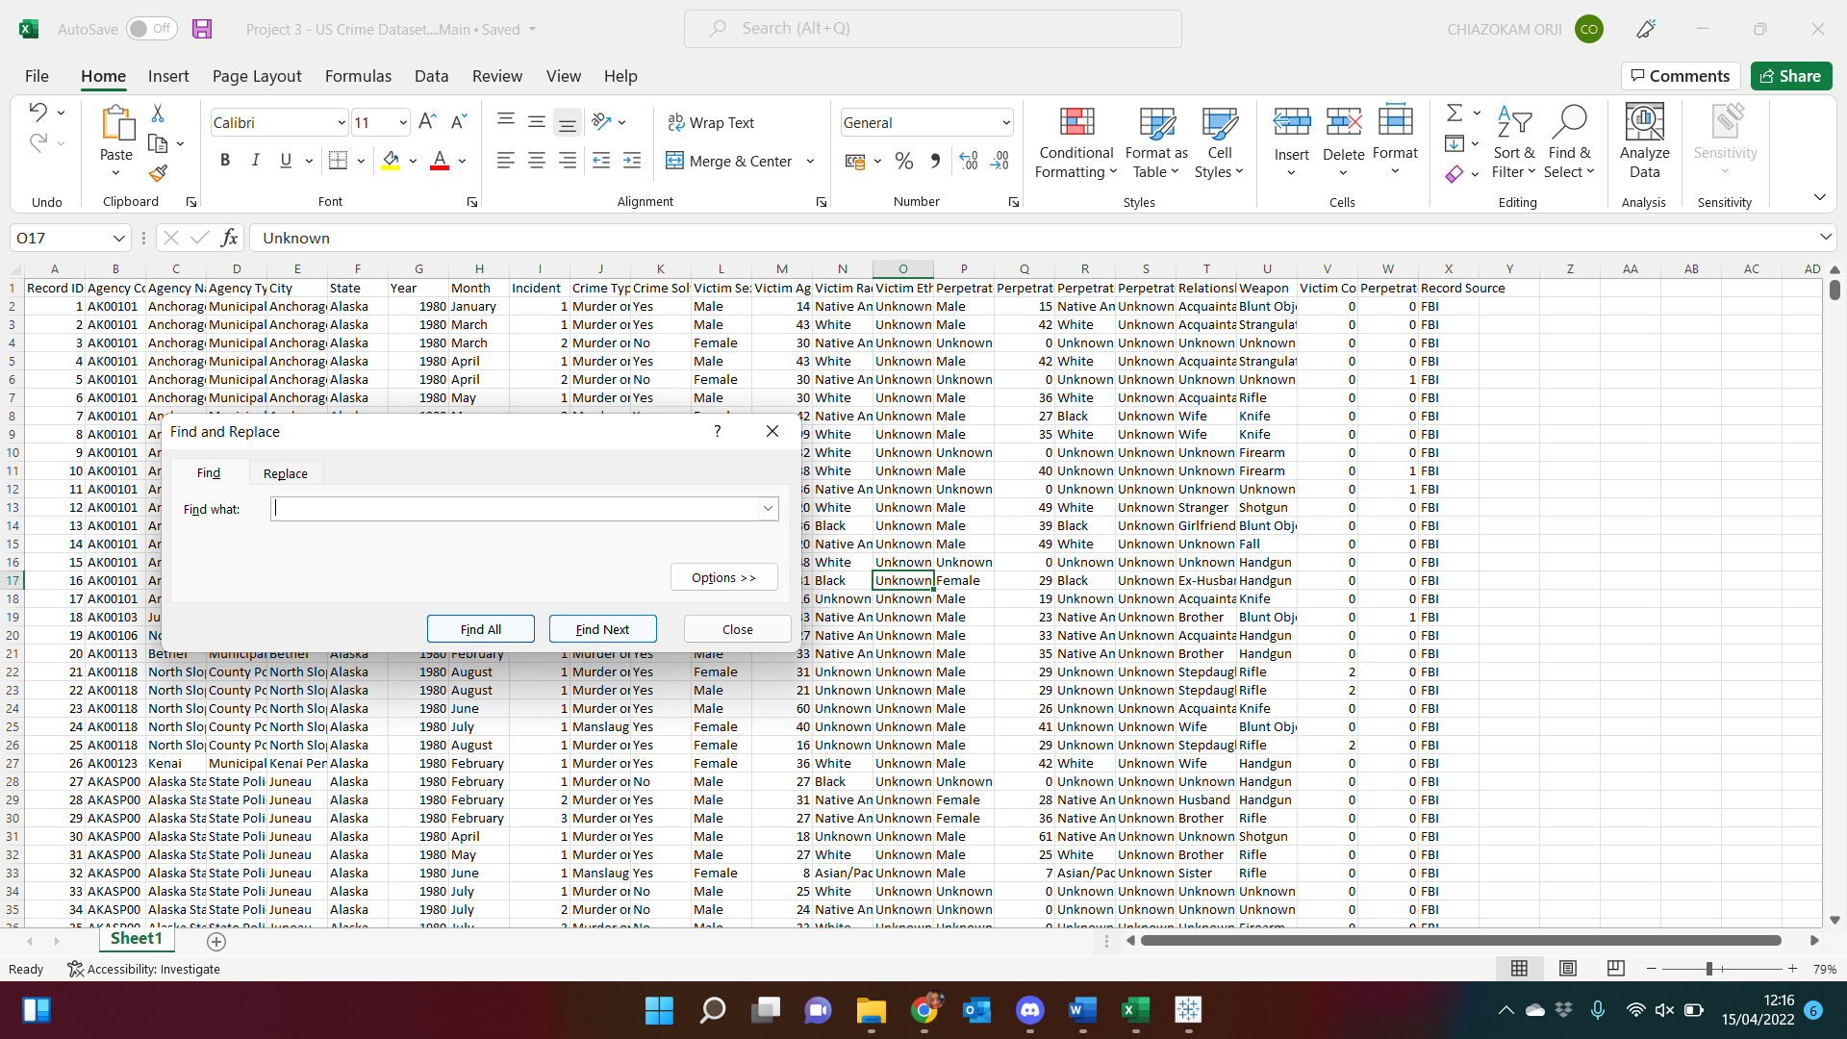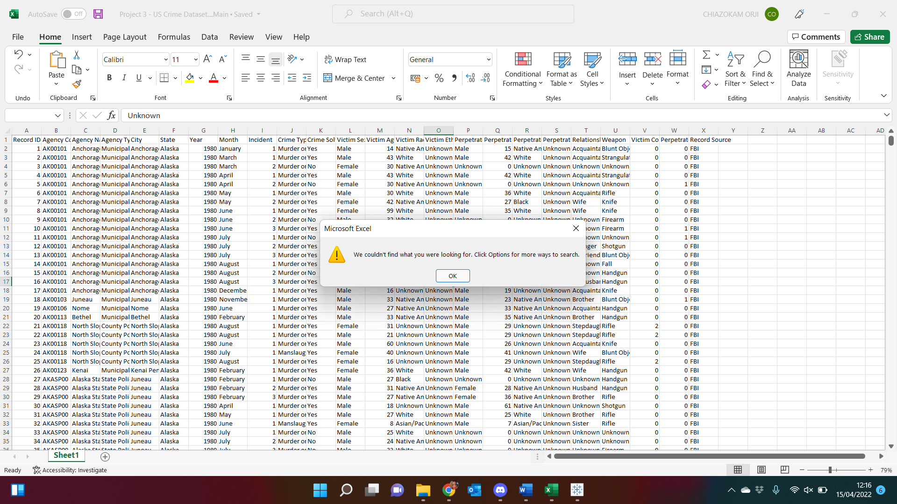 



* **Addition of a new Column:** I noticed there was no column for country name, so I manually added a new column on the excel sheet, named the header ‘Country’ and populated the entire fields with ‘USA’. This can be seen in the screenshot below.

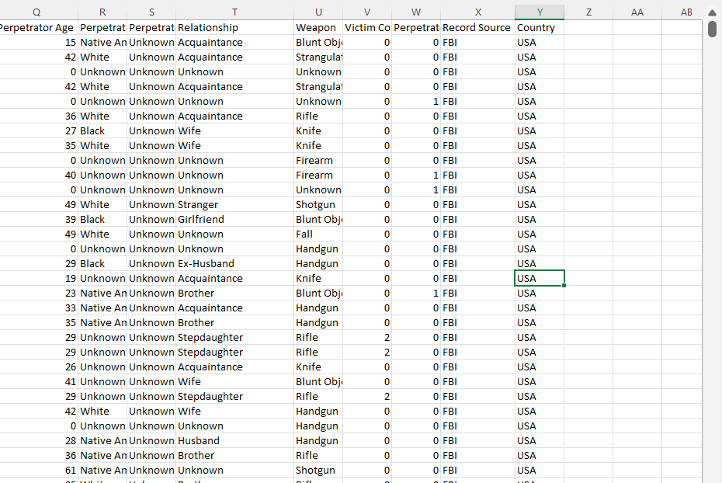





* **Characteristics of the dataset:** In trying to further study the data, I saw that the source of the data was from two sources, FBI and FOIA. I noticed that not all the crimes were solved. 70.2% of the crimes were solved while 29.8% were unsolved. Also, majority of the victims belong to either the black race or the white race with the victims belonging to the black race contributing 46.27% while the victims who are white contribute 49.72%. Another observation is that 77.39% of the victims are men while the women are 22.45%.

**4th March                            3rd Team Meeting**

My Team members and I continued with data exploration and familiarization and observed that a lot of unknown values existed in different fields in the dataset. These unknown values signified the information either didn’t exist or were not recorded. Extracting meaningful information from unknown fields seemed slightly difficult so I contemplated removing the entire observation but decided to seek professional advice. Below is a screenshot showing the observations with unknown values.

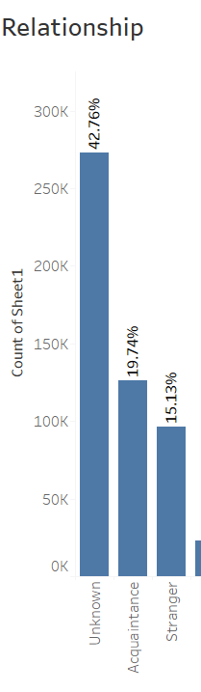 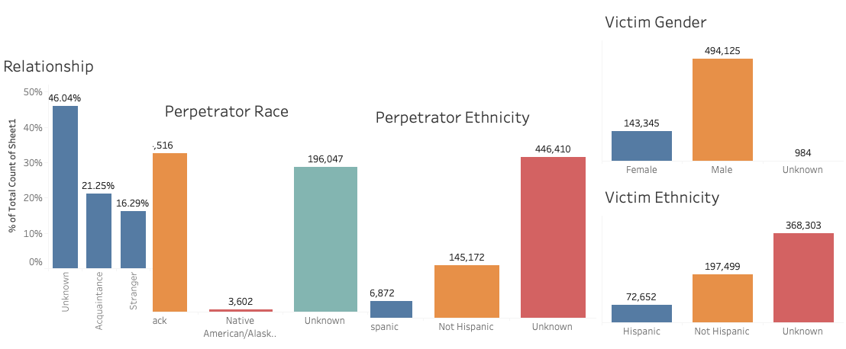 

**9th March**

I proceeded to inform my lecturer, Haixia, about this observation and sought her advice on how to handle them. I was advised to focus more on the known values and less on the unknown. I went ahead to remove the observations where the unknown values were very high such as in Perpetrator race, Perpetrator ethnicity, and Victim Ethnicity. However, although there are many unknown values in the ‘Relationship’ field, I decided to analyze this field further and I was able to derive an explanation from the dataset. I observed 29.8% of crimes were unsolved and crimes where the ‘Relationship’ is unknown made up 93.61% of unsolved crimes. This suggested that a crime where the relationship is unknown is likely to go unsolved compared to where the relationship is known.

The screenshot below is a dashboard visualization of the relationship between the victim and perpetrators and the percentage of solved and unsolved crime. ‘Yes’, in the darker shade of red indicates solved crime while ‘No’ in the lighter shade of red indicate unsolved crime.

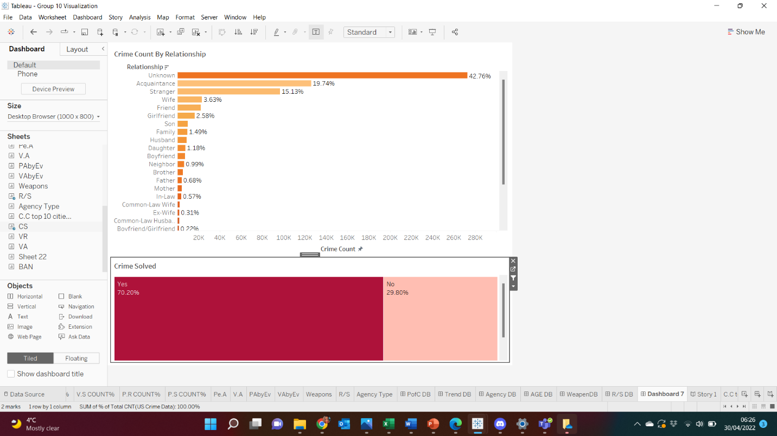

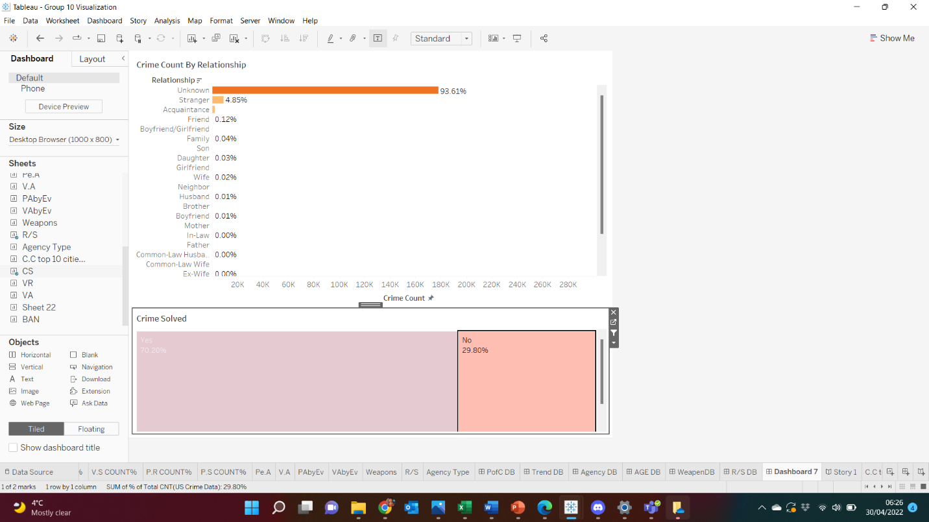



**11th March                              4th Team Meeting**

My team and I met today to conclude our Milestone 1. During the meeting, I noticed an issue when trying to visualize the incident column and brought this to my group’s attention. The field had numbers greater than 900 while Exploring the data and overall, very random values. We tried to visualise this column again using range or bins but were not satisfied with the outcome.

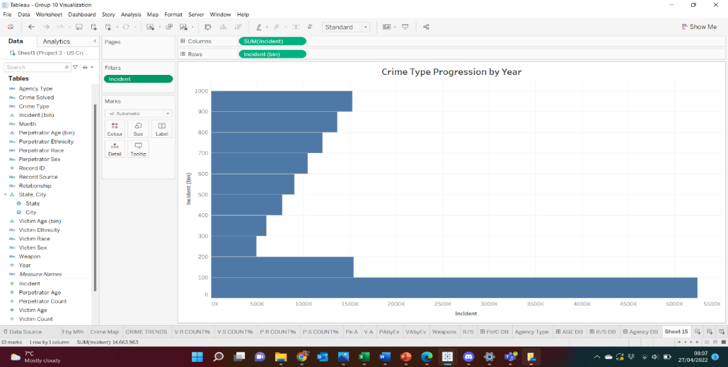

I discussed this with Haixia on the 13th of March and she advised that instead of using the ‘incident count’ column to represent the total count of crime recorded, we should use Sheet 1(Count of Crimes) which I renamed ‘US Crime Data(Count)’ It shows the record of the entire event.

**14th March**

Today, we had a very interesting and insightful lecture on Reflective writing and Reflective diary taught by Emma Delaney from the library team. I learnt a lot of things but the most important lesson I took from that lecture was that any reflective diary must be supported by references/sources and that it is very important to use the right phrases in my reflective diary. This made go back to my diary and make necessary corrections and adjustments.

**Milestone 2        Starting 3rd Week of March**

**18th March                              5th Team Meeting**

Today, my team and I started working on the second milestone to understand the needs of the business environment, identify potential stakeholders who would be interested in this data and answer their questions from the dataset.

Before the meeting, I reviewed Milestone 2 requirements and realised I was not sure who the stakeholders are so I took a closer look at the dataset to figure out who will be interested in the findings and outcome of this analysis. They are the law enforcement agencies, government or governing bodies/agencies, insurance companies and the entire public. Of all the relevant stakeholders, the major stakeholders are Law Enforcement Agencies, the Government, and the Communities.

Law Enforcement Agencies are important stakeholders because they use information obtained from a crime analysis relevant, efficient, and effective management and executive decision making. Regardless of the constant ongoing debates and discussions on the limitations of crime analysis, its importance in assisting law enforcement agencies and their communities with understanding and responding to criminal activities cannot be overemphasized. These stakeholders rely on the outcome of the crime analysis to an extent to tackle crimes. Crime analysis helps to develop theories surrounding crime pattern and trend that will assist stakeholders to review and advocate for existing policies, as well as develop ideal public and private policies to tackle crime. It also gives law enforcement agencies a level of knowledge to respond to crime and overall, help everyone involved to attain a common goal, which is a secure and dependable society.

My teammates and I came up with business questions below:



**21st March   2nd Industry Advisor Meeting**

We had our second Industry Advisor meeting today and amongst so many things, the advisor spoke to us on how to treat empty cells in the excel column of the dataset used for an analysis.

I asked the Industry Advisor a question regarding how to treat the empty cells when the columns are either categorical or numerical values and was told that Categorical values should be replaced with ‘Unknown’ while that of numerical values should be replaced with ‘Zero (0)’ to avoid errors in the visualization. I also went back to review my dataset to ensure compliance with the above.

**23rd March**

My team and I were to commence with Milestone 3 at the next meeting which would involve a lot of visualizations. I, therefore, decided to go through the lecture we had with Haixia in week 5 especially on ‘Preattentive Attribute-colours’, the difference between warm colours and cool colours and scenarios or contexts to use them. I also reflected on the need to consider the colour-blind and leverage brand colours.

I also reflected on the lecture held on the 9th of February where Dr. Paul Matthews taught us ‘Visual Perception, Cognition and Design’. I reflected on the purposes of visualisation listed and the cognitive principles (Hegarty, 2011) where the ‘Relevance Principle of Graphics’ says to only use exact information needed by the audience for visualisations. Other cognitive principles like ‘The Principle of Capacity Limitations’ reminded me to consider limitations in working memory and attention, when designing my visuals, ‘The Principle of Compatibility’ reminded me that it is easier to understand a visual display if there is a compatibility between the form and its meaning. Finally, ‘The Principle of Appropriate Knowledge’ made me ensure to infuse enough information into my visualizations to provide the viewer with sufficient and relevant knowledge (Hegarty, 2011).

**Milestone 3                        Starting last week of March**

**25th March                              6th Team Meeting**

Today, my team and I started working on the 3rd milestone where we had to create and identify relevant visualizations to help answer the business questions stated in Milestone 2. I created prototypes of the visualizations and they can be found below.

**Business Question 1: Which State in the United States had the most crime occurrence and why?**

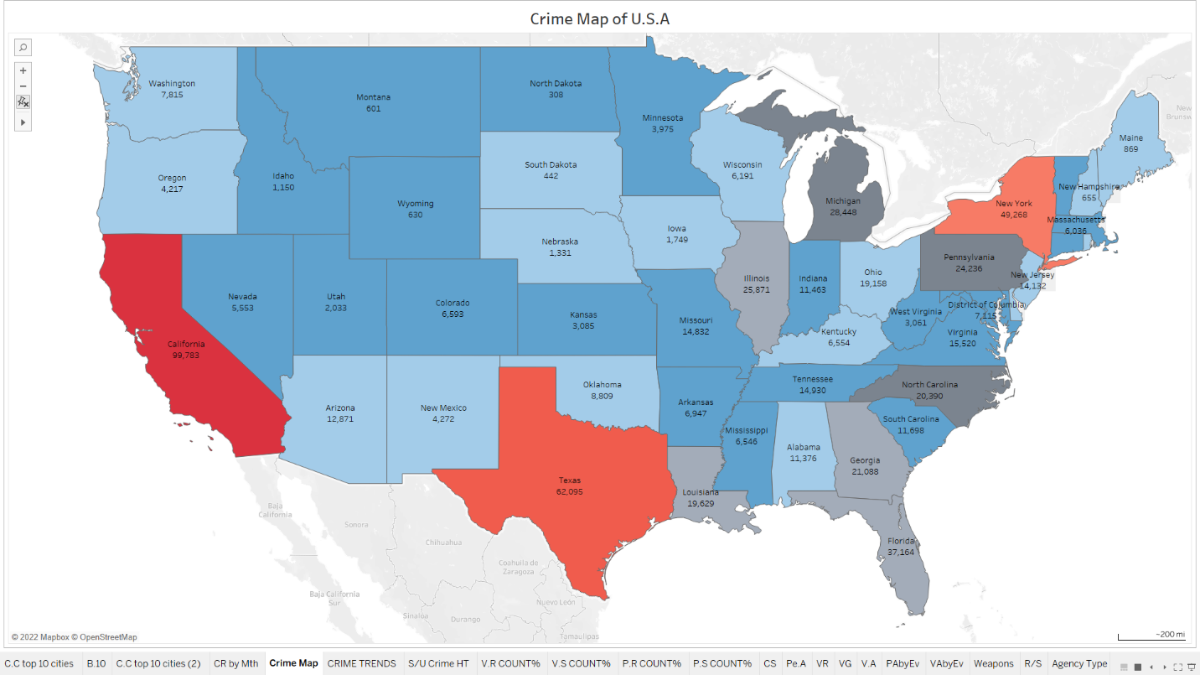



The screenshot above is the map of the United States of America which shows different states and the crime events recorded in each State. The map shows that California has the highest crime event recorded in the dataset with a total of 99,783, followed by Texas and New York. I used different shades of two colours. The red shades signified danger or high-risk and were used to signify the three states with the most crime recorded, and the darkest red shade reflected the State with the highest crime. The choice of colours was made with a huge consideration for the colour-blind.

I noticed that in addition to California being the State with the most crime in the dataset, according to Statista Research Department, California also has the highest population. It has been established that there is a relationship between the size of a population and the volume of crime (Nolan, 2004).

**Business Question 2: What were the crimes recorded in the dataset?**

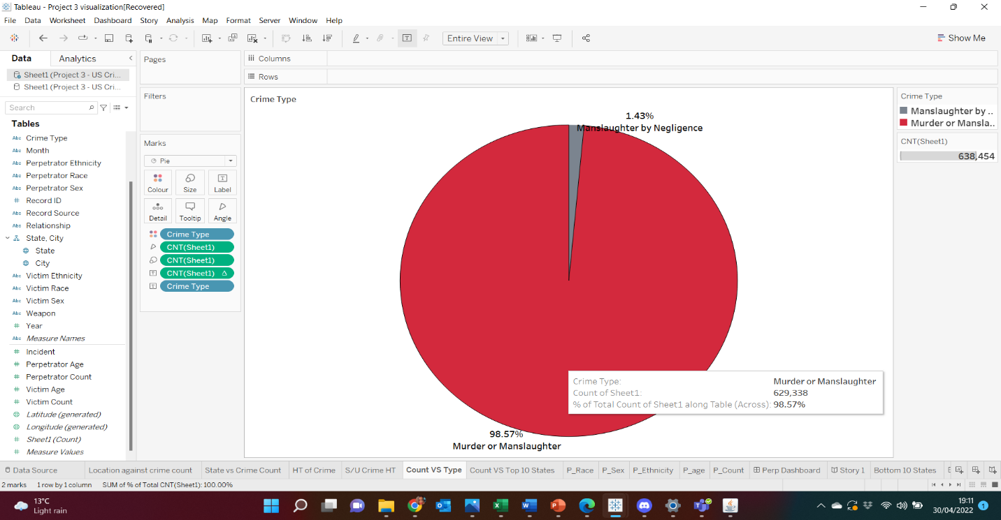

I used a pie chart to visualise the crime types. Manslaughter by Negligence was represented with grey and contributed 1.43% to total count while Murder or Manslaughter represented in red contributed the most with 98.57%.

**Business Question 3: Is the crime count recorded annually progressing or regressing in the United States?**

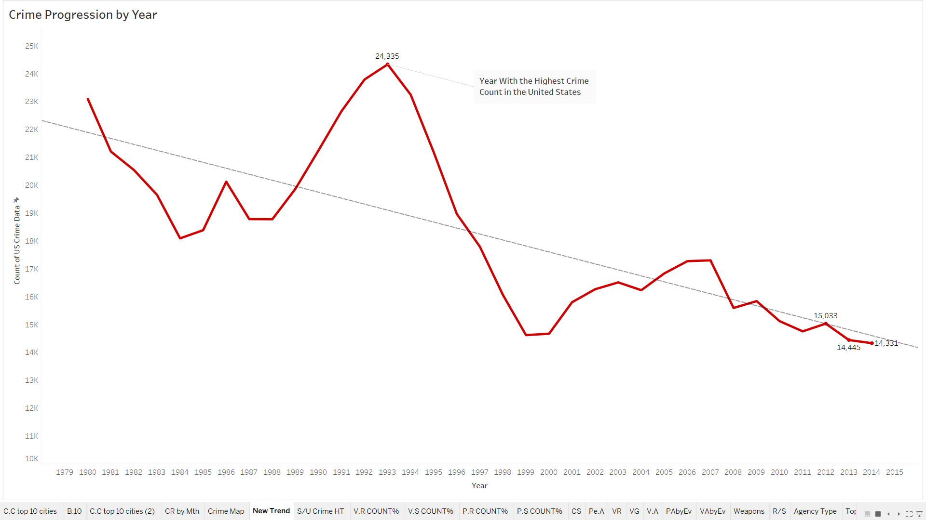



I used the line chart to illustrate the progression of crime from 1980 to 2014 in the United States. The chart shows the crime trend clearly and will give my audience appropriate visual context. The chart shows a deep in the count of crime after 1980 and an increase after 1988, reaching its peak in 1993. After 1993 which is the year with the highest crime count, the trend started declining. Overall, the trend line shows a decrease in crime in the US.

**Business Question 4: Out of the crime events recorded in the dataset, what percentage was solved and unsolved?**

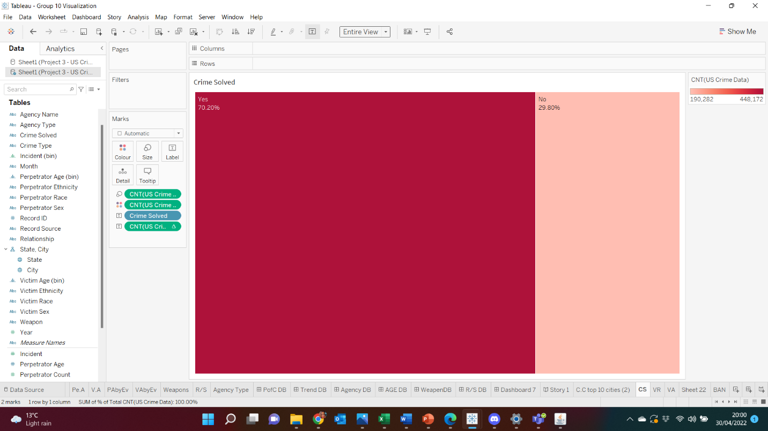



`The visualization above displays the percentage of crime solved. The darker shade of red represents crimes solved which is 70.2% and higher than the unsolved crimes which is 29.8%. Therefore, we have more solved crimes than unsolved crimes in the dataset.

**Business Question 5: Which weapon proved the most used to commit these crimes?**

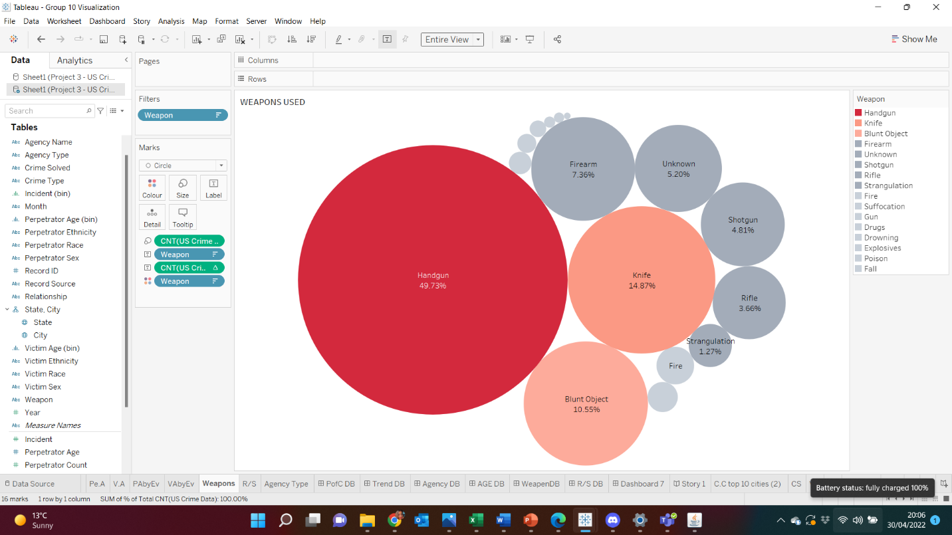

I got the idea to use a bubble chart from my lecturer, Haixia. Since red represents danger, different shades of red was used for the three most used weapons with the darkest shade indicating the most used weapon, the handgun. I tried getting the attention of my audience by leveraging pre-attentive attributes in terms of color.

**Business Question 6: Which age group is mostly targeted and which age group committed the most crime?**

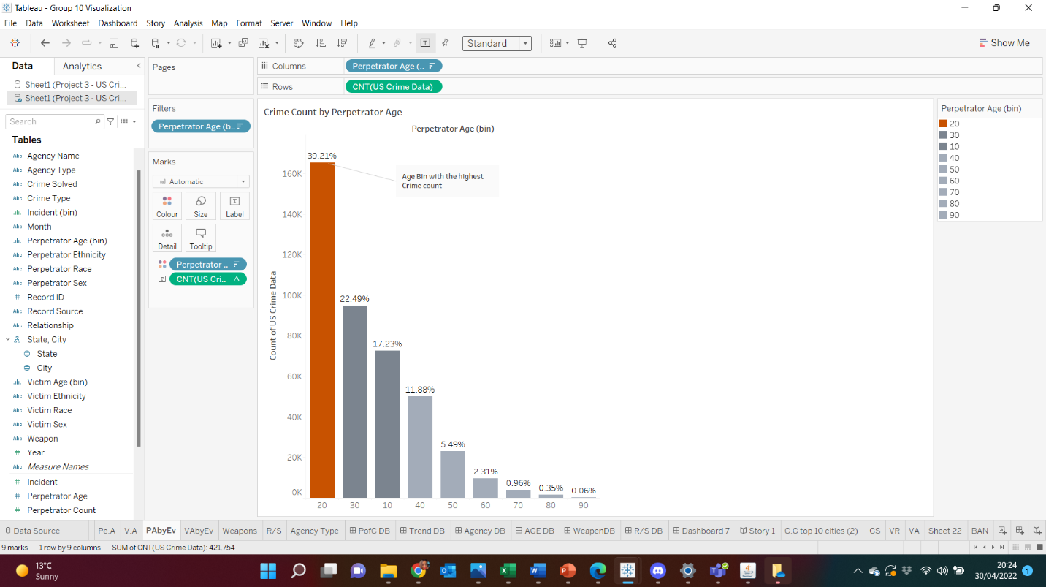 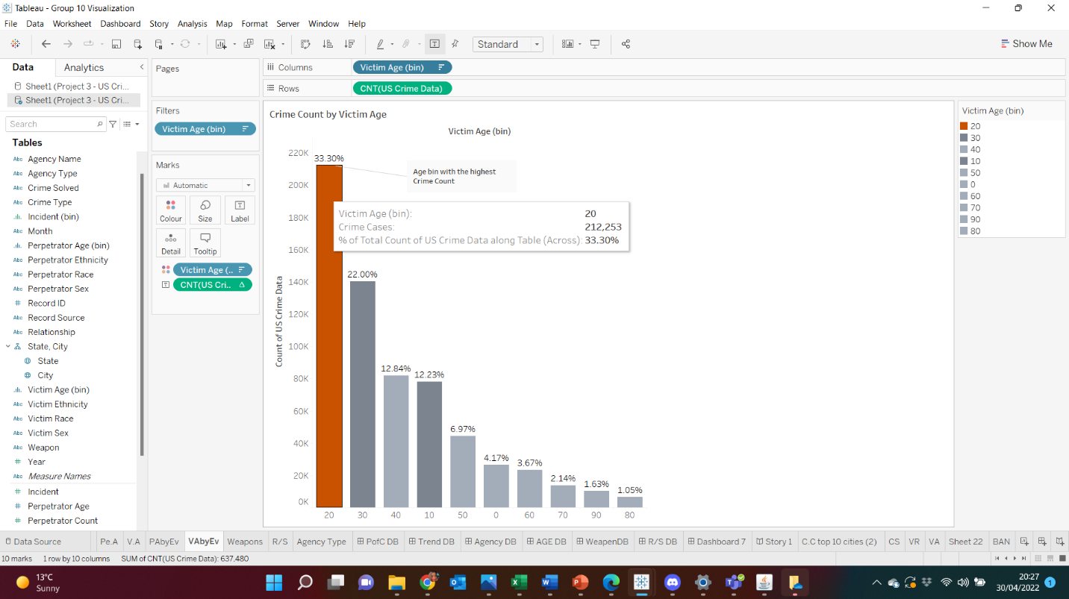

I used a bar chart for the visualization. I tried to visualize the age, but they were many and couldn’t fit in the chart properly. So, I grouped the ages into age bins of 10 and chose colours from the colour blind palette with the dark orange signifying the age bin with the most perpetrators and victims, that is age bin 20. Perpetrators and Victims are predominantly in their 20s. I also noticed most of the perpetrators (about 40+ %) are about 28 years of age. This is either an anomaly or shows attention needs to be paid to people around this age and the 20s age group in general.

**Business Question 7: What kind of relationship exist between the Perpetrators and the Victims and which of these relationships is the most dominant?**

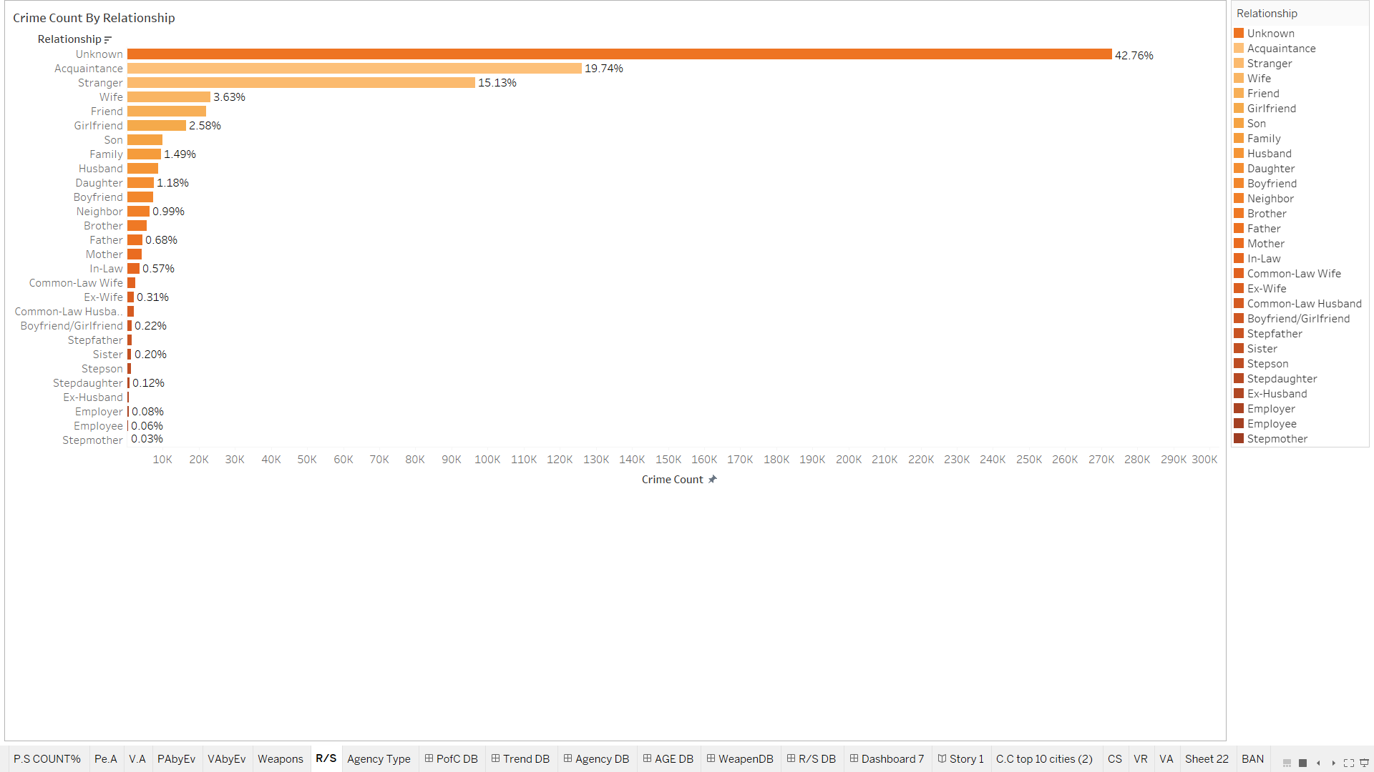

I used the vertical bar chart to display the relationship between Perpetrators and Victims and the orange color shades because it’s the color of outfits worn by inmates in prison. The reason for choosing the color was due to its similarity with prison uniforms in the US.

**Business Question 8: Which of the Agencies recorded in the dataset solved the most crime and are the Victims reporting these incidents to relevant agencies?**

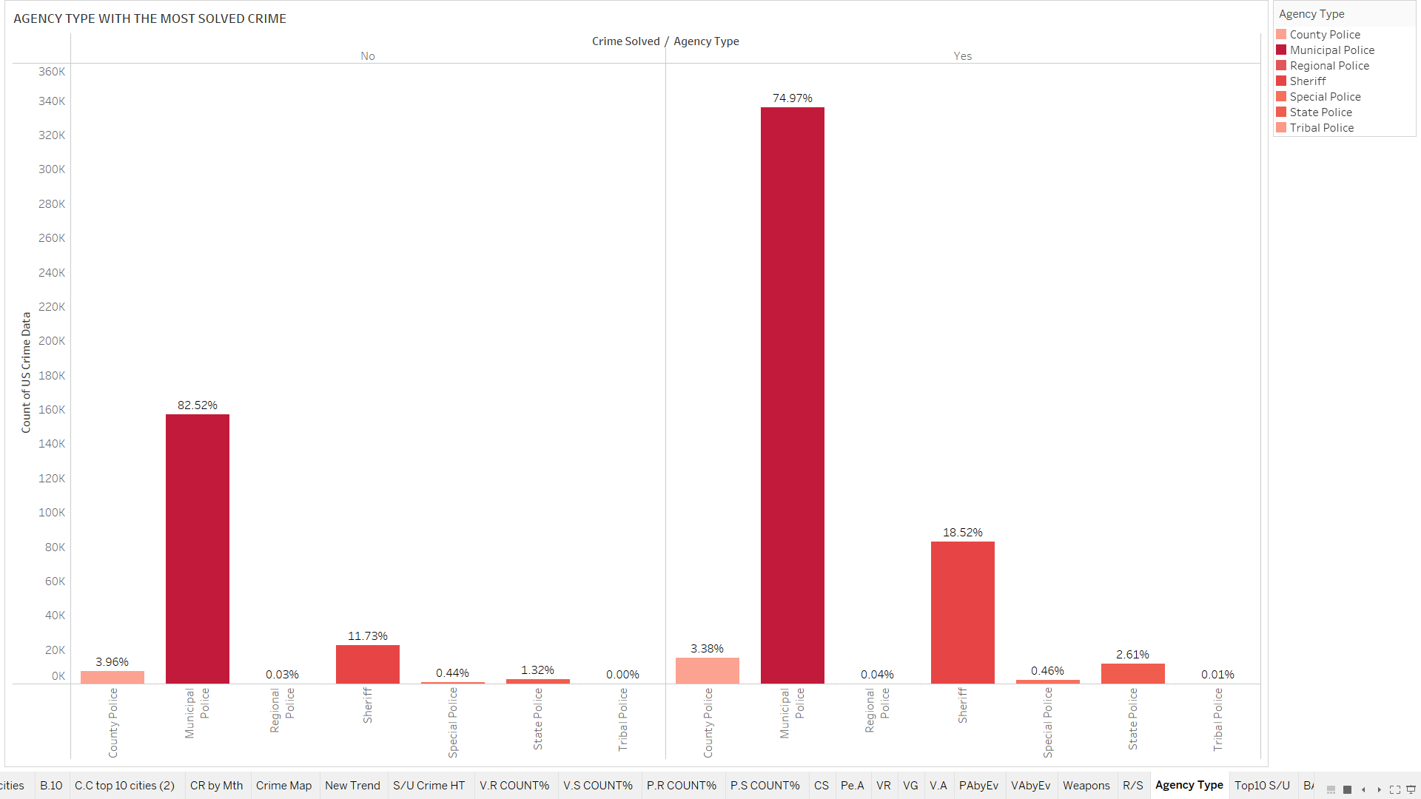 

The chart shows which agencies solved the most crime and this reflects the number of criminal cases they receive. Municipal got the most reported cases; they are controlled by the local government and easily accessible to the public.

However, the image below shows the number of percentage of cases solved by each agency based on cases assigned to them. This shows that, Tribal police resolved the most cases, which is 92.59% of the number of cases assigned to them.

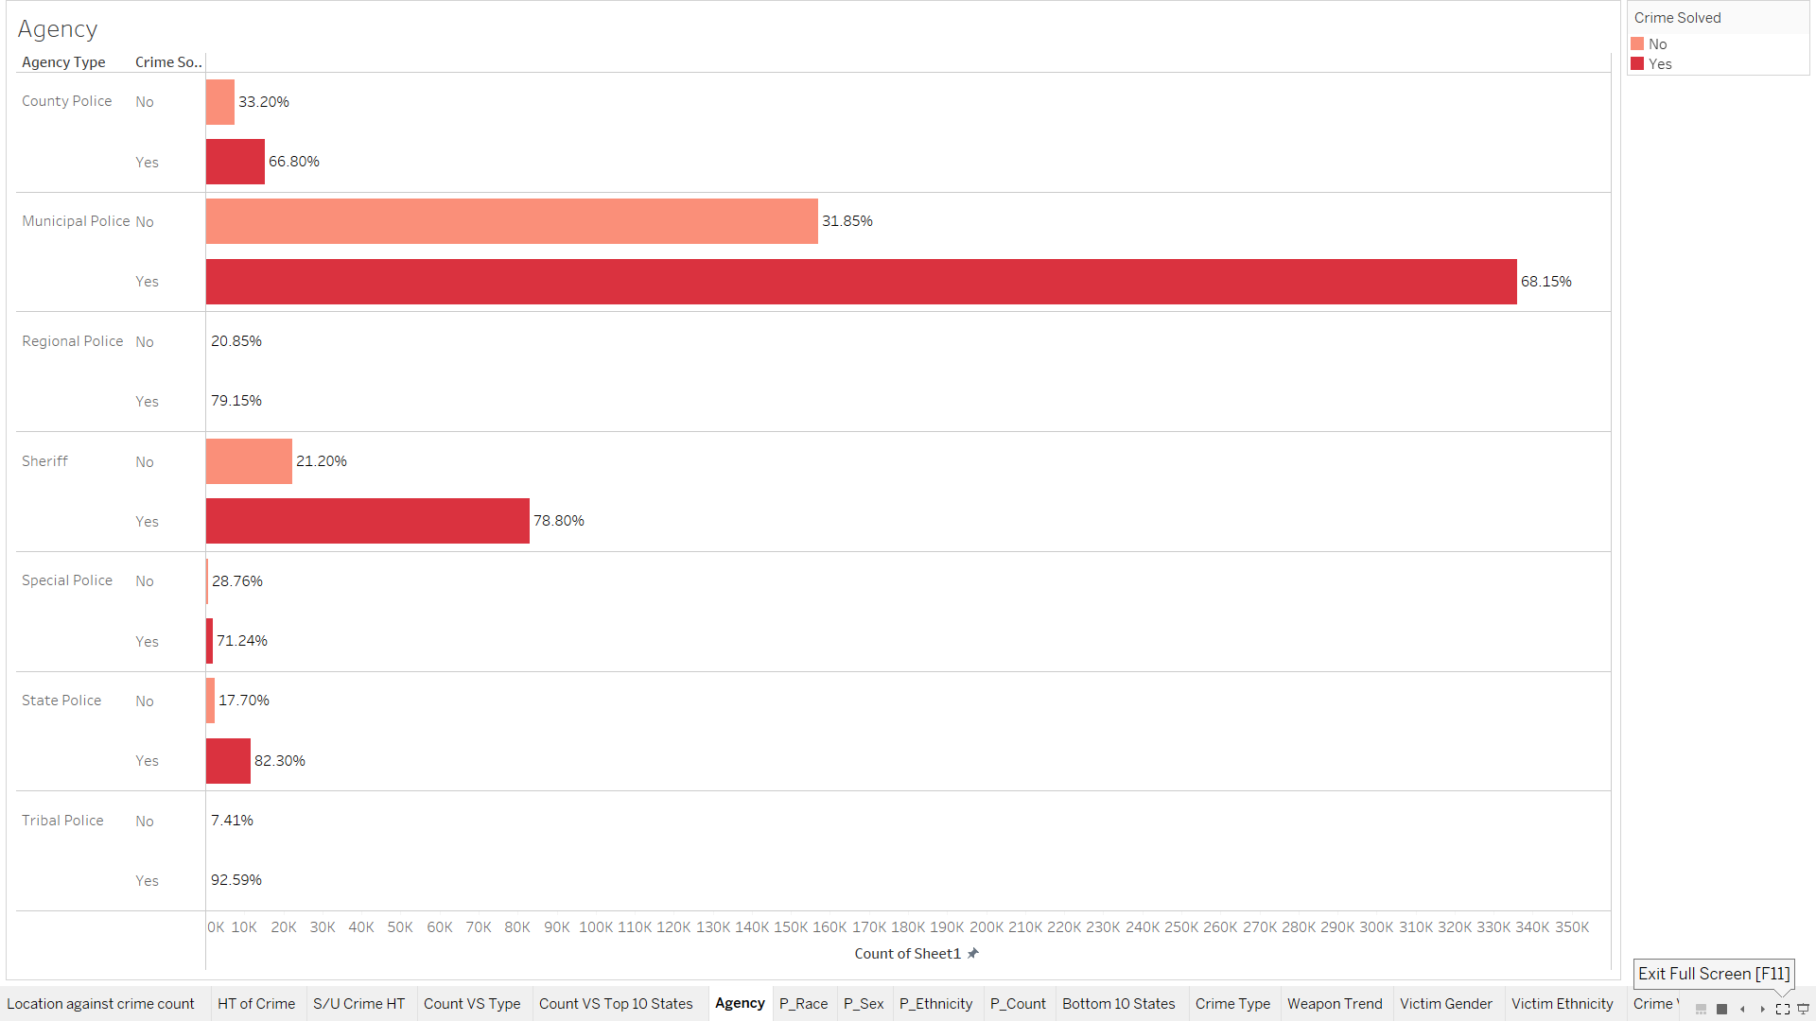



**Milestone 4                        Starting last week of March**

**1st April                              7th Team Meeting**

Today, we commenced Milestone four to develop a narrative that summarizes the data, but we had to create dashboards using our visualizations to properly tell a story. We spent the entire meeting putting our dashboards together.

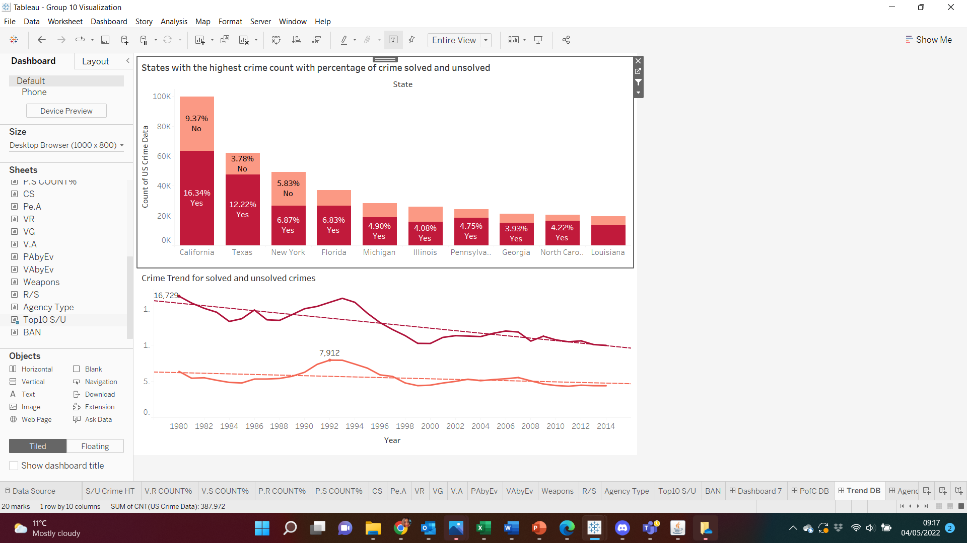



**8th April                              8th Team Meeting**

My team and I proceeded to develop a narrative today, where I learnt that the power of storytelling to connect facts cannot be overemphasized (Knaflic, 2015)

Out of the dashboards created, the ones below had features that caught my attention.

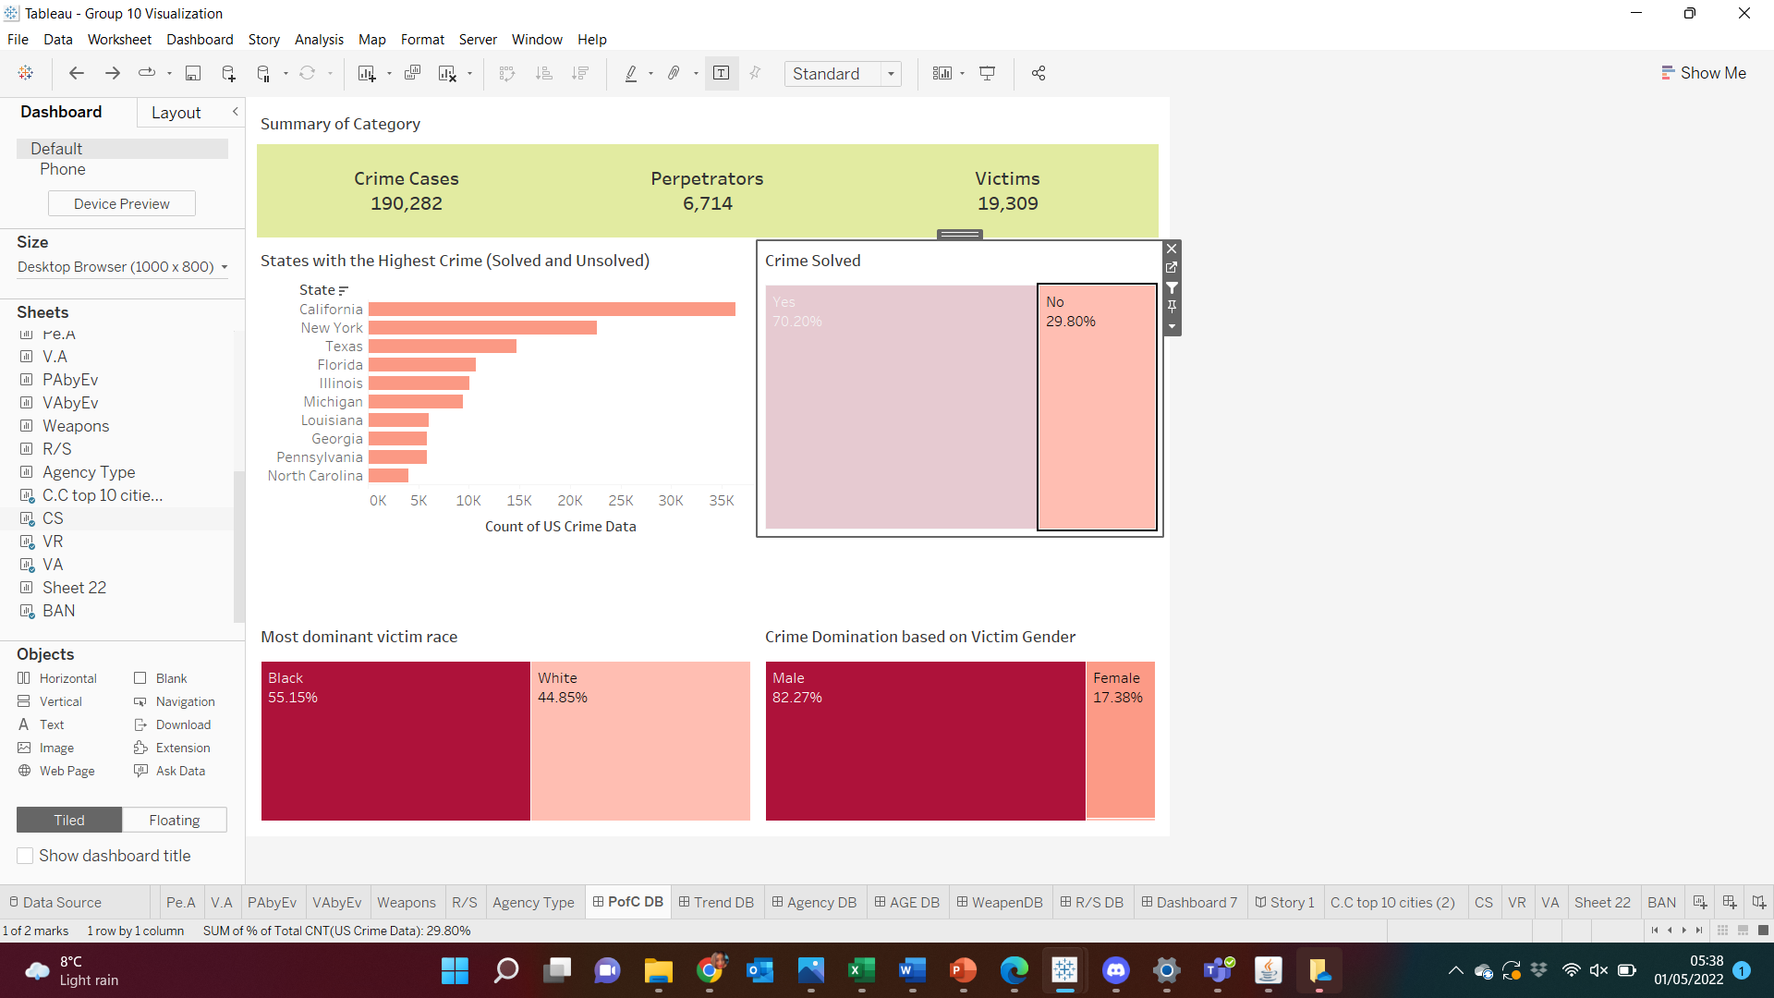



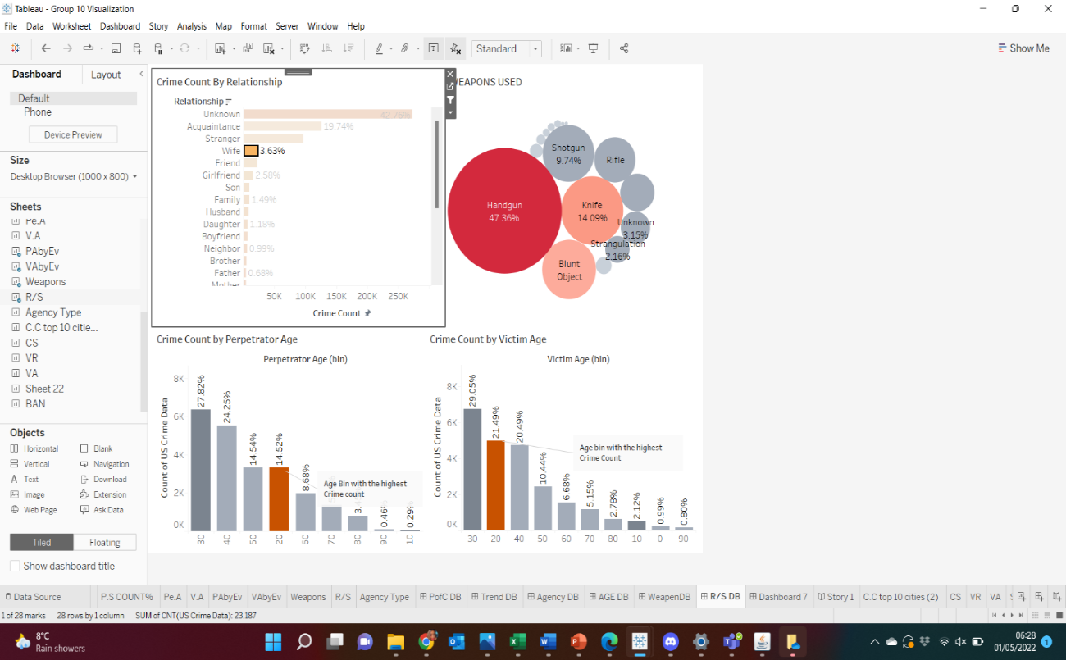 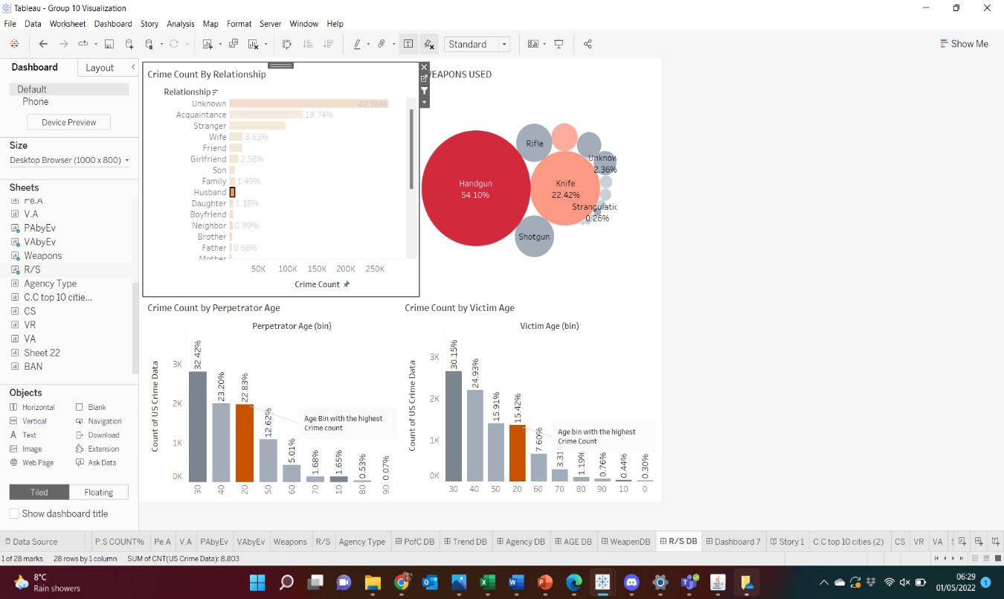



**Fig 17**. Shows the States with the most crime in the United States and the crimes that are unsolved. California, Texas, and New York are the top three states, in that order.

It also shows that although the crime solving rate is high, majority of the unsolved crimes, the victims were men. Also, we had more white victims than black victims in the dataset but unsolved crimes against black victims were the highest. This could suggest a form of racial bias and the crime committed against white people receive more attention.

Also, there are more white victims and perpetrators in the US, and this is because according to *Statista Research Department (2021)*, the white race has the highest population in the US.

**Fig 18.** shows that although Perpetrators and Victims are predominantly in their 20s, where the relationship between the Perpetrators and Victims are husband and wife had predominantly Perpetrators and Victims in the 30s age bin unlike the other relationships. This makes sense because at that age, a lot of adults are married. Attention should be paid to married couples in their 30s especially in domestic abuse cases.

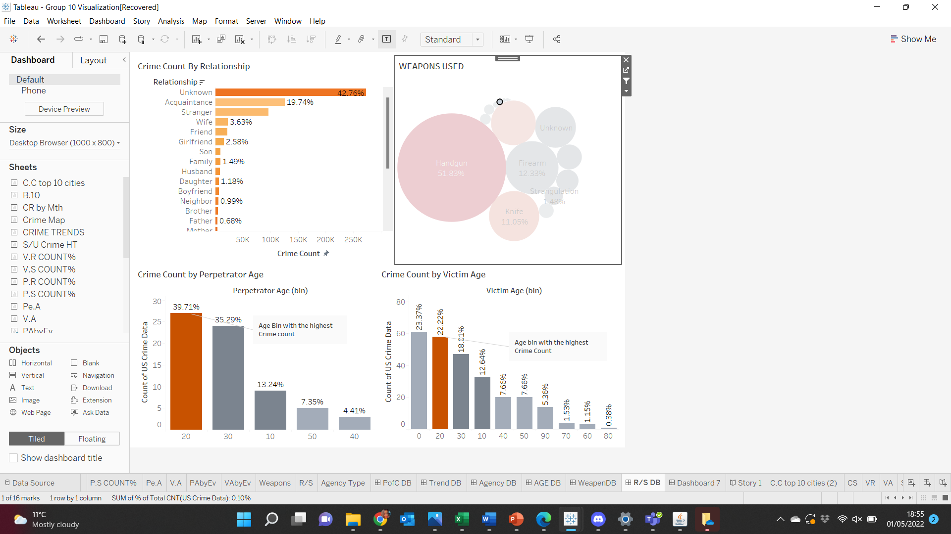



**Fig 19.** shows that although handgun is the most used weapon for the predominant age group in the dataset, the crimes due to drowning were highest amongst age 0 – 9 age bins, the youngest age group.

**15th April                               8th Team’s Meeting**

We had a meeting to review and conclude our visualizations and dashboards while working on our reflective diaries. I went through the book Haixia advised us to read on storytelling and watched the YouTube video shared on Aula. The book available in the online library proved interesting too. The use of pre-attentive characteristics to draw audience’s attention to an information was suggested (Knaflic, 2015).

**22nd April                               9th Team’s Meeting**

We reviewed our project and how far we have come today. We also decided to put our questions together ahead of the industry advisor meeting coming up.

**25th April                                3rd Advisor Meeting**

Our last advisors meeting held today. The industry advisor spoke to us about the different types of dashboards and the need to create dashboards that will answer the questions of different stakeholders. I proceeded to ask the advisor how the dashboards should be represented and if we’re to answer the same question with different dashboards for stakeholders. He advised us to create dashboards that will send messages based on their needs.

**29th April                                          10th Team’s Meeting**

I showed Haixia our team’s dashboards on the 27th of April and she advised we consider the fact we have only 15minutes for the presentation and consider reducing the number of dashboards in our storyline. Today’s meeting was used to decide on what to do, which dashboard to remove.

**Milestone 5                     Started last week of April**

**30th April Recommendation**

At the end of my analysis and storytelling, I had sufficient information to make necessary recommendations to my stakeholders especially the law enforcement agencies. The recommendations are:



**1st May Limitations**

Today, I reflected on the limitations and challenges experienced during the analysis and they are outlined below.



**Learning Outcomes**

During the project, I was able to review existing crime analysis literature and they gave me more insight and helped provide guidance for my own analysis. I learnt the importance of crime analysis in tackling and reducing crime in the society.

I reflected on the entire process of this crime analysis, going through all the trials, errors, and corrections. I can say I have a better understanding on how to create engaging and appropriate visualizations using Tableau. I was also able to understand the need and gain the ability to effectively communicate a data-driven storyline to relevant stakeholders.

I learnt the use of effective visuals in my charts as well as trend lines. In using trend lines, I ensured there was ‘zero’ value to be satisfied with the outcome of the p-value.

I leveraged on the Cognitive Principles taught by Dr. Paul and ensured to use Preattentive attributes to differentiate between attributes in the dataset and display their hierarchy while also ensuring the use of colour consistently and with consideration towards the colour blind.

In conclusion, I have developed highly efficient problem-solving, tactical, analytical, team-playing, communication, and management skills through this project. I plan to continue to apply Business Intelligence and Data Visualization towards deriving meaningful information through data processing, data analysis, pattern identification, and storytelling, and effective communication.

# References

Anon., 2019. Gross Negligence Manslaughter. [Online]   
Available at: https://www.cps.gov.uk/legal-guidance/gross-negligence-manslaughter  
[Accessed 28 April 2022].

Anon., 2022. Resident population of the U.S. in 2021, by state (including the District of Columbia). [Online]   
Available at: https://www.statista.com/statistics/183497/population-in-the-federal-states-of-the-us/  
[Accessed 30 April 2022].

Cairo, A. and Ackerman, S., n.d. The truthful art: effective visual communication of information [Accessed 29 April 2022].

Cps.gov.uk. 2021. Homicide: Murder and Manslaughter | The Crown Prosecution Service. [online] Available at: <https://www.cps.gov.uk/legal-guidance/homicide-murder-and-manslaughter> [Accessed 25, April 2022].

Fas.org. 2021. [online] Available at: <https://fas.org/sgp/crs/misc/R45236.pdf> [Accessed 28, April 2022].

Gramlich, J., 2020. What the data says (and doesn’t say) about crime in the United States. [Online]   
Available at: https://www.pewresearch.org/fact-tank/2020/11/20/facts-about-crime-in-the-u-s/  
[Accessed 29 April 2022].

Hegarty, M. (2011) The cognitive science of visual-spatial displays: Implications for design, Topics in Cognitive Science, 3(3) [Accessed 29 April 2022].

James, N., 2018. Recent Violent Crime Trends in the United States. [Online]   
Available at: https://sgp.fas.org/crs/misc/R45236.pdf  
[Accessed 29 April 2022].

# Knaflic, C., n.d. Storytelling with data. : the effective visual communication of information

[Accessed 28, April 2022].

Nolan, J. J. I., 2004. Establishing the statistical relationship between population size and UCR crime rate: Its impact and implications. [Online]   
Available at: https://theipti.org/wp-content/uploads/2012/02/covariance.pdf  
[Accessed 30 April 2022].

Ogochukwu, O. F. O. a. O., 2021. AN OVERVIEW OF CRIME ANALYSIS, PREVENTION AND PREDICTION USING DATA MINING BASED ON REAL TIME AND LOCATION DATA. International Journal of Engineering Applied Sciences and Technology, February, Vol. 5(Issue 10, ISSN No. 2455-2143), pp. Pages 99-103.

Statista Department of Research, 2021. Resident population of the United States by race from 2000 to 2020. Statista. [online] Available at: <https://www.statista.com/statistics/183489/population-of-the-us-by-ethnicity-since-2000/>[Accessed 04, May 2022]

Stuart Miller Solicitors. 2021. A Guide to Manslaughter by Gross Negligence | Stuart Miller Solicitors. [online] Available at: <https://www.stuartmillersolicitors.co.uk/guide-manslaughter-gross-negligence/> [Accessed 25, April 2022].